Appendix. Proofs of lemmas and propositions in the main paper
Proof of Lemma 1.
For part (1), taking the first-order partial derivative of equilibrium outcomes with respect to k, we have:
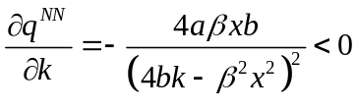, 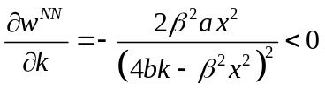,
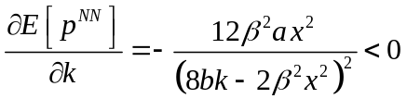, 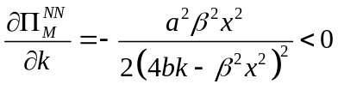,
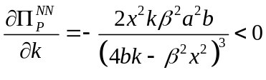.
For part (2), taking the first-order partial derivative of equilibrium outcomes with respect to x, we have:
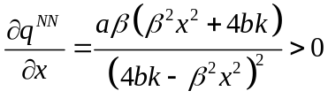, 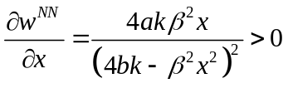,
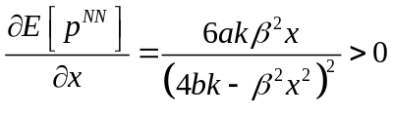, 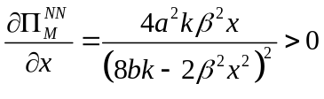,
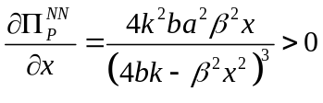.
Proof of Lemma 2.
Proof of Lemma 2 is similar to the Proof of Lemma 1, therefore, it is omitted.
Proof of Lemma 3.
For part (1), taking the first-order partial derivative of equilibrium outcomes with respect to k, we have:
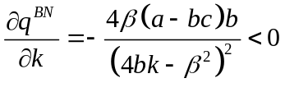, 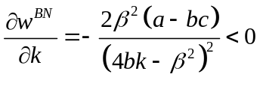,
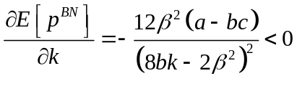, 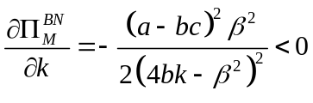,
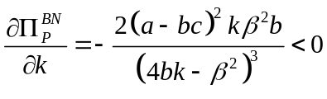.
For part (2), taking the first-order partial derivative of equilibrium outcomes with respect to c, we have:
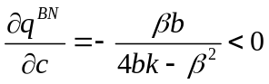, 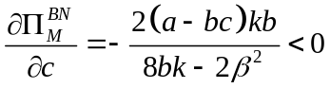,
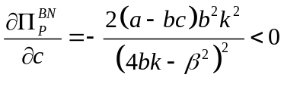.
For part (3), taking the first-order partial derivative of 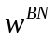 with respect to c, we have: 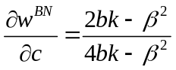. It is easy to obtain that when 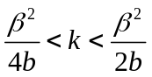, then 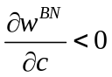; when 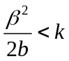, then 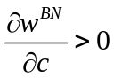.
For part (4), taking the first-order partial derivative of 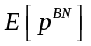 with respect to c, we have: 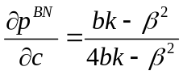. It is easy to obtain that when 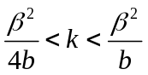, then 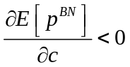; when 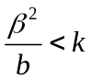, then 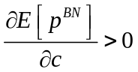.
Proof of Lemma 4.
Proof of Lemma 4 is similar to the Proof of Lemma 3, therefore, it is omitted.
Proof of Lemma 5.
For part (1), 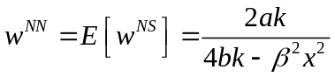, 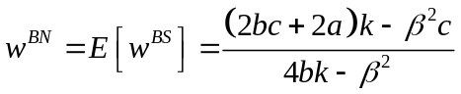.
For part (2), from the proof of part (1), there is 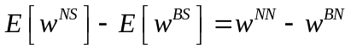, therefore, we only take the difference between 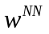 and which is as follows:
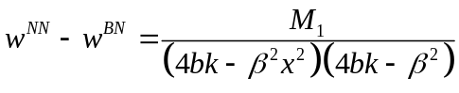,
where . Because the numerator 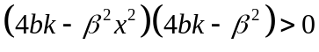, the sign of 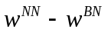 depends on 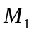. By calculating the first-order partial derivative of with respect to c, we can obtain 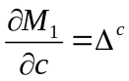. To determine the sign of 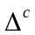, we calculate the the first-order and second order partial derivative of with respect to k, and get 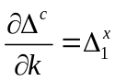, 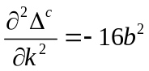. Therefore, 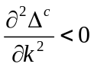, 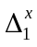 decreases in k. To determine the sign of , first check the endpoint values,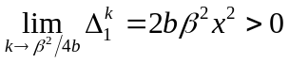 and 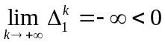, it can be obtained that is first positive and then negative. Therefore, first increases and then decreases in k. To determine the sign of , first check the endpoint values, 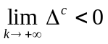 and 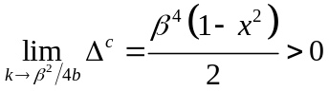, there exists a zero point of , let 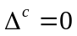, we have 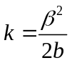. Therefore, when 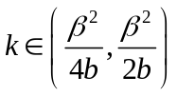, is positive, increases in c, when 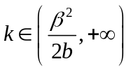, is negative, decreases in c. Next, we determine the sign of . When , 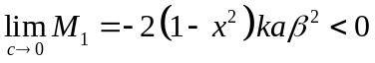, 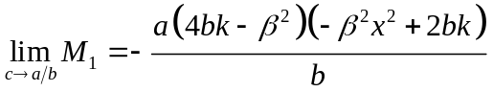. If 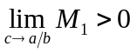, we have 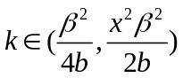 and 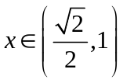, there exists a zero point 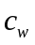, where 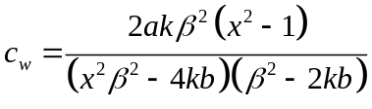, which makes 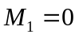, when 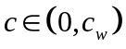, 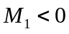, when 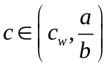, 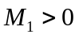. If 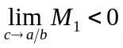, , by solving the inequation, we can easily obtain the condition that 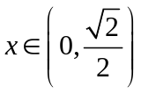 and 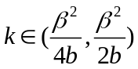 or and 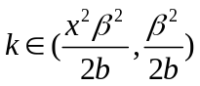. Next, when , , . A summary of the above mathematical proof leads to the conclusion of Lemma 5 (2).
Proof of Lemma 6.
Proof of Lemma 6 is similar to the Proof of Lemma 5, therefore, it is omitted.
Proof of Proposition 1.
It can be easily verified that 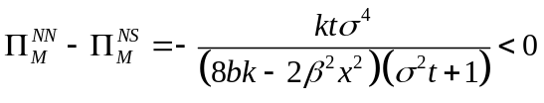. Then we check the following profit difference:
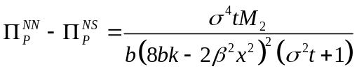
where 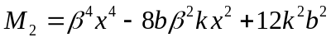. By calculating the second-order partial derivative of 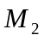 with respect to k, we can obtain 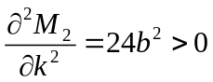. Therefore, 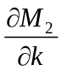 increases in k, we have 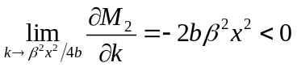 and 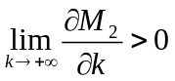, so there exists a zero point 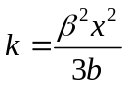 that makes 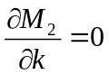. Therefore, first decreases and then increases in k. We have 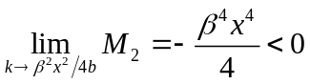 and 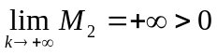, there exists a zero point between 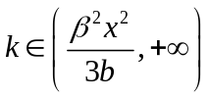, let 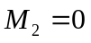, it can be obtained that 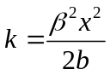. Therefore, is negative when 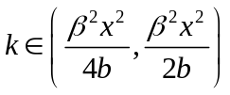, is positive when 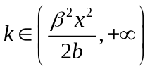. Proposition 1 has been proven.
Proof of Proposition 2.
Proof of Proposition 2 is similar to the Proof of Proposition 1, therefore, it is omitted.
Proof of Proposition 3.
To obtain the manufacturer’s blockchain adoption strategy, we first list four important thresholds which are solved in section 4 in the main paper and in Proposition 1 and Proposition 2: 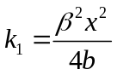, 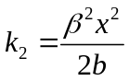, 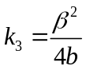, 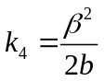. The meaning of these thresholds can be understood by referring to the descriptions in the main paper and are not overly described here.
For part (a), if , 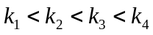. When 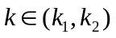, there exists only one equilibrium strategy combination which is NS. When 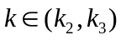, there exists only one equilibrium strategy combination which is NS. When 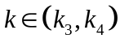 there exists two strategy combinations which are NN and BS. The task here is to find the equilibrium strategy combination. We take the profit difference of the manufacturer under the two scenarios which is given by:
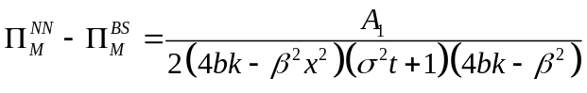,
where 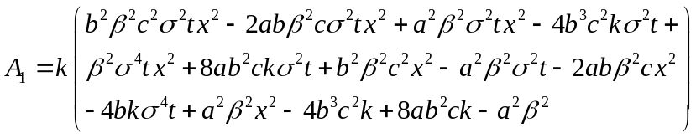. By calculating the first-order and second-order partial derivative of  with respect to c, we can obtain 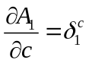 and 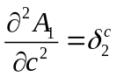. Then, by calculating the first-order and second-order partial derivative of 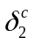 with respect to k, we can obtain 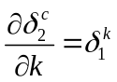 and 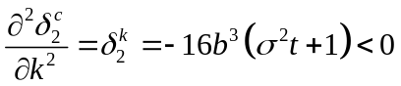. Therefore, 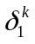 decreases in k, it can be easily verified that 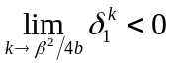, so 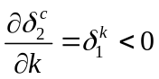, decreases in k. We check the value of left endpoint and it can be verified that 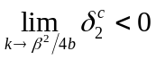, so 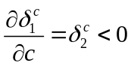, 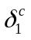 decreases in c. We check the endpoint value of and it can be verified that 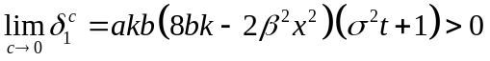 and 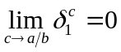, so 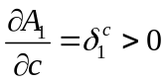, increases in c. Note that 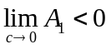 always holds, so we check the right endpoint value of which is given by:
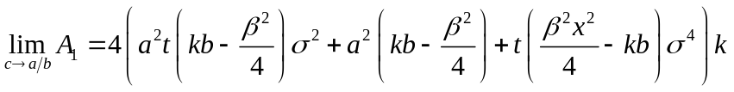,
it can be easily verified that there exist a threshold 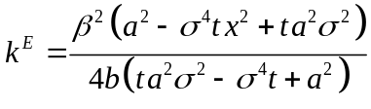, when 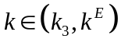, 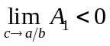, then 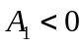. When 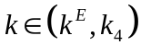, is first negative and then positive as c increases, so, there exists a zero point 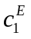 which can be solved by setting 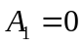, the specific expression of is given in the main paper. Therefore, if 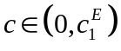, ; if 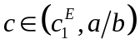, 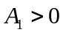. Then the equilibrium strategy combination in the range of follows directly. Next, we move to the range of 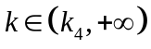, there exists two strategy combinations which are NN and BN. We take the profit difference of the manufacturer under the two scenarios which is given by:
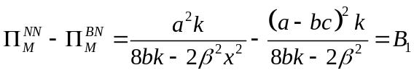.
By calculating the first-order and second-order partial derivative of 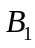 with respect to c, we can obtain 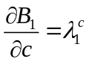 and 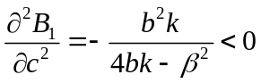, so 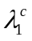 decreases in c. We check 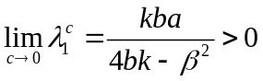 and 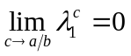, so 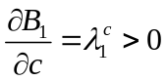, increases in c. Further note that 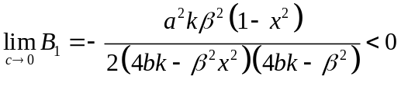, meanwhile, 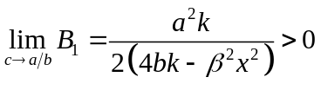, therefore, there exists a zero point 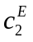 which can be solved by setting 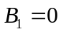, the specific expression of is given in the main paper. Therefore, if 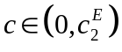, 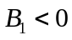; if 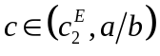, 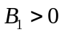. Then the equilibrium strategy combination in the range of follows directly.
For part (b), the proof is similar to that of part (a), therefore, it is omitted.

